
TAI CHI GUNG RETREAT

A DROGMI BUDDHIST INSTITUTE FUNDRAISER
Fri 12 – Sun 14 Oct
WITH VENERABLE BUL HAE SUNIM AND

GLENDA MORGAN

come and join us for a wonderful weekend of
gentle movement / breathing exercises known AS tai
chi gung that have been practiced for
thousands of years for health, well being and
happiness in the surrounds of the BEAUTIFUL
kamilashila buddhist CENTRE in tilba.



TOPICS COVERED INCLUDE :

- Basics of Chinese Medicine
- Tai Chi Gung Shibashi
- Heaven and Earth Form
- Eight Piece Golden Brocade Form
- Zen/ Taoist Meditation
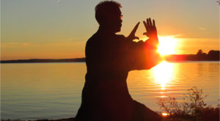

All meals will be vegetarian and
prepared according to Chinese
medicine dietetics

- BOOKINGS ESSENTIAL AS PLACES ARE LIMITED.
Full 2 day retreat $220.00 [includes accommodation/ all meals]
Full 2 day retreat $170.00 [includes day meals/ no accommodation]
I Day only $85 [includes all meals]

- CONCESSIONS AVAILABLE
For more information and bookings email Bul Hae on bulhaesunim@hotmail.com

