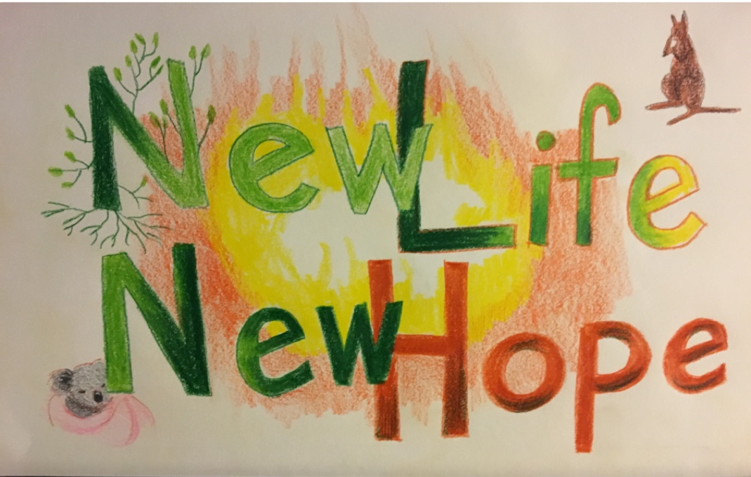

SUNDAY JANUARY 10th 2021

SINGING AND DRAMA WORKSHOPS AND PERFORMANCES

MUMBULLA SCHOOL AMPHITHEATRE 37 Bega St Bega

with Wayfarers Australia singers, actors and instrumentalists aged 6 to adult

directed by Judith Clingan AM

1. **THE LORAX – MUSIC THEATRE**

Based on Dr Seuss’ words, with music by Judith Clingan

**DRAMA AND SINGING WORKSHOP FOR AGES 6 – 14**

**10.30 am – 11.50 am**

Workshop participants will then join the Wayfarers singers/actors and instrumentalists

in a **performance of *The Lorax.* 12.00 – 12.45 pm**

1. **NEW CHORAL SONGS**

**WORKSHOP for adults and young people who love singing**

**2.00 pm – 3.00 pm**

Learn two new choir songs in parts (soprano, alto, baritone)

Workshop participants then join Wayfarers in their concert of new choral songs

**PERFORMANCE: 3.00 pm – 4.00 pm**

Admission to all events by donation: all money donated to go to Cobargo Wildlife Sanctuary

Bookings for workshops essential: [judithclingan@me.com](mailto:judithclingan@me.com) / 0410 617 427